INTERFAITH MORAL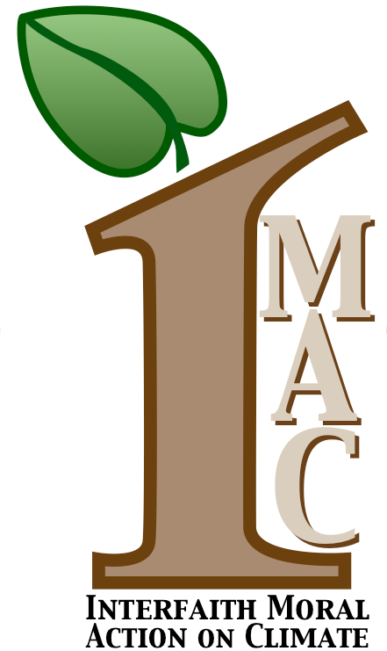 ACTION ON CLIMATE
www.interfaithactiononclimatechange.org

January 9, 2015

The Honorable John Boehner The Honorable Mitch McConnell
Speaker of the House Majority Leader
U.S. House of Representatives U.S. Senate
H-232 US Capitol S-230 US Capitol
Washington, DC 20515 Washington, DC 20510

Dear Mr. Speaker and Majority Leader McConnell:

Interfaith Moral Action on Climate is a collaborative initiative of more than 100 religious and faith-based leaders and organizations (see attached list of endorsers) who are calling for urgent action to address the deepening climate emergency.

We write to you as you assume leadership of the 114th Congress so you clearly understand that the significant constituencies of religious communities we represent are looking to you to actively support and enact policies that deal responsibly with the climate crisis.

As you know, religious leaders of all faiths have sounded the alarm.

Pope Francis, for example, speaking not only to the Roman Catholic Church and the world-wide Christian community but to all humanity, has said that climate change, with its devastating impacts affecting the poor and vulnerable most severely “…represents a serious ethical and moral responsibility." He has announced plans to release a Papal Encyclical on climate and its impact on humanity, and to convene a meeting of the world’s religious leaders to collectively embrace the appeal he made to international negotiators at the climate conference in Peru last month, when he said, “The time to find global solutions is running out. We can find adequate solutions only if we act together and unanimously.”

Similarly, Dr. Martin Luther King, Jr., whose 86th birthday on January 15th falls auspiciously in the middle of your Party’s legislative summit in Hershey, Pennsylvania, spoke passionately of our obligation to address pressing social justice issues. Today, for increasing numbers of religious leaders and their congregants, climate change is the moral issue of our time. As we see that the first victims of the extreme weather events that define this crisis are the innocents occupying the lowest rungs of the socio-economic ladder, we recall Dr. King’s prophetic words. “Ultimately,” he said, “a great nation is a compassionate nation. No individual or nation can be great if it does not have a concern for ‘the least of these.’”

On Thursday, January 15th at 12:00 noon, IMAC will honor Dr. King’s birthday by holding an interfaith service outside of the Hershey Lodge where you will be discussing with your Republican colleagues the legislative agenda for the coming year. We invite you or your representatives to participate with us in this service to demonstrate your commitment to provide urgently-needed leadership to solve the climate crisis. We would also welcome the opportunity to meet with you or your designees before or after the service.

Please respond to IMAC Steering Committee member, Cynthia Harris at imaclimate@gmail.com regarding your availability.

Respectfully,
The Steering Committee
Interfaith Moral Action on Climate

